Faisal Eraiqat
Mr. Mangan
ESS
9 November 2016
TASK 1
- Define soil degradation
decline in soil quality caused by its improper use, usually for agricultural, industrial or urban purposes
2. Identify the factors responsible for soil degradation
Erosion, pollution, loss of soil fertility, loss of vegetation, desertification
3. Explain how those factors cause soil degradation.
Destroys the soil, no plants can grow, makes soil weak and will break down, resulting in a loss of land and it becomes unable to grow vegetation and be used.
4. Make a fishbone diagram: Recognize the various human activities that lead to soil degradation, identify the processes and consequences of it. Refer to the resources in next slide

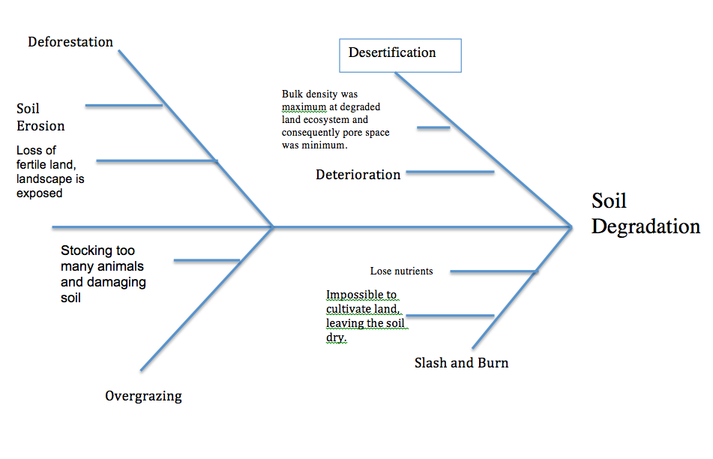

5. Named case study of soil degradation

Case Study of the UK

In the UK, farmlands are getting affected by soil degradation, which will eventually come to harm the UK’s economy, particularly the agricultural sector. Soil degradation in the UK is the consequence of farmers increasing their hardcore farming practices, such as deep ploughing, rapid crop-rotation and bigger fields, free of trees, which means that wind and rain can easily blow away the top layer of soil, where most of the nutrients lie.
However, farmers are affected negatively, in particular potatoes and vegetables, seeing as those two are the main crops grown by the UK, as part of its commercial farming.

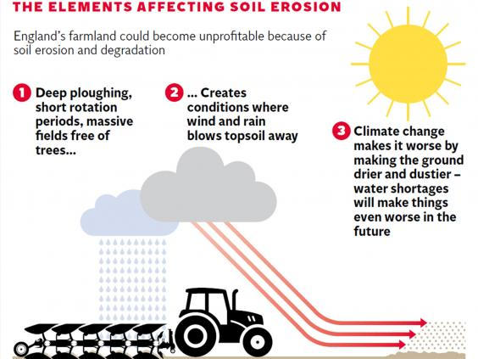

In the case of the UK, it is wind erosion which is occurring. Wind erosion is when the wind sweeps everything, such as seen in the diagram above.

The UK, as a result, have decided to keep a close eye on its soil and instead of taking it for granted, the government has decided to declare soil as a mined resource, making it one of the most valuable resources in the UK.

UAE: Human activities are causing soil degradation in the UAE. 90% of the farms around Al Ain have salinity problems. Irrigation is causing salt to build up in the soil which causes soil to break down and become desert (desertification). Also, off-road vehicles and overgrazing is damaging the surface layer as it compacts it and leaves it prone to wind erosion. These human activities lead to very poor wildlife habitat and ecosystem destruction. There are also natural factors leading to soil degradation, including drought, wind erosion, and sand encroachment (when grains of sand are carried by winds and collect on the coast along water courses and on cultivated or uncultivated land).
An emirate-wide action plan is also needed to be developed and implemented to manage and combat all types of degradation. To slow down soil degradation, there are many projects in place. One is the forest planting projects that are successful in slowing erosion. Farmland can be protected by making more efficient the use of irrigation water and develop proper drainage to allow the salt to leach out of the soil. Also, planting forests or trees create windbreaks and stop sand dunes shifting. Currently, afforestation has been practices on about 330,000 ha in Abu Dhabi. This is a preventative measure for some of the desert lands that are not yet degraded or are only slightly degraded. Through various strategies, the Abu Dhabi emirate can lessen the effects of soil degradation.

TASK 2
1. Identify human activities responsible for soil degradation and identify the processes and consequences of it
2. Use the following table as template
Activity ca Activities caused by humans | Processes | Consequences | Soil Management
Overgrazing | Stocking too many animals and damaging soil | Soil breaks down and prevents plants from growing | Make designated areas
Overcropping | Over cultivated land and nutrients gone | Nutrients are depleted and unable to grow more crops | Legislation
Deforestation | Cutting down forests | Loss of fertile land, landscape is exposed | Legislation against this
Pollution | Pesticides, garbage, harmful chemicals | Breakdown of nutrients and contaminated soil means no plants will grow | Legislation and restrictions on harmful chemicals to be sold and used
- What do you understand by unsustainable agricultural techniques? List the various unsustainable agricultural techniques.
Unsustainable agricultural techniques are maneuvers done in the agricultural sector, which leads to more or less depletion, since it does not account for the future of the generations.

- Industrial farming (focuses on monoculture, which decreases the diversity) (Polyculture is much stronger and sustainable)
- GMOs
- Overproduction
- Natural vegetation cleared and farmland plowed
- Using too much water

- Define Erosion and deposition
Erosion is the actions and processes of removing soil, rock, or dissolved material. While deposition is the process in which sediments, soil, and rocks, are added to a landform or land mass.
- Outline the causes of soil Degradation
  - Physical factors: rainfall, surface runoff, floods, wind erosion, tillage (the preparation of land for growing crops), and mass movements result in loss of fertile top soil. These produce different types of soil erosion (mainly water and wind erosion) and soil detachment actions. This eventually changes the composition and structure of the soil by wearing away the soil’s top layer as well as organic matter.
  - Biological factors: human and plant activities that reduce quality of soil. Plant activities include some bacteria and fungi overgrowth in an area that impacts microbial activity of soil through bio-chemical reactions, reducing crop yield and suitability of soil productivity capacity. Human activities include poor farming practices as it depletes soil nutrients.
  - Chemical factors: alterations in soil’s chemical property that determine nutrient availability. Examples are reduction of soil nutrients because of alkalinity or acidity or water logging. Mainly caused by salt buildup and leaching of nutrients.
  - Human activities: deforestation (exposes soil minerals and availability of humus while increasing infiltration rates), misuse of fertilizers (add too many chemicals to soil that seeps into groundwater), urbanization (removes soil’s vegetation over, compacts soil during construction, alters drainage pattern).

- Explain the causes of a loss of productivity
- Overgrazing
- Overproduction
- Inefficient allocation
- Loss of nutrients
- Pollution
- These result in a loss of productivity as the soil is not the most efficient and the inputs will not generate the greatest amount of outputs.

5. Identify solutions for a sustainable agriculture
- Crop rotation: growing different crops in succession in the same field. Solution to pest problems are pests have preferences for specific crops so continuous growth of same crop guarantees steady food so populations increase. Also, crop rotation replenished plant nutrients in the same soil are which reduces the need for chemical fertilizers.
- Cover crops: planting cover crops like hairy vetch, clover, or oats helps prevent soil erosion, suppress weeds, and enhance soil quality. Also reduces need for chemical inputs like herbicides, insecticides, and fertilizers.
- Soil enrichment: leaving crop residues in the field after harvest, plowing under cover crops, or adding composted plant material or animal manure.
- Natural pest predators: using natural predations of agricultural pests limits the need for intensive use of chemical pesticides which kills birds, bats, and can lead to runoff.
- Biointensive Integrated Pest Management (IPM): relies to the greatest possible extent on biological rather than chemical measures and emphasizes the prevention of pest problems with crop rotation; reintroduction of natural, disease-fighting microbes into plants/soil, and release of beneficial organisms that prey on pests (natural pest predators).

