Faisal Eraiqat
Task 4
1. Create a Soil food web

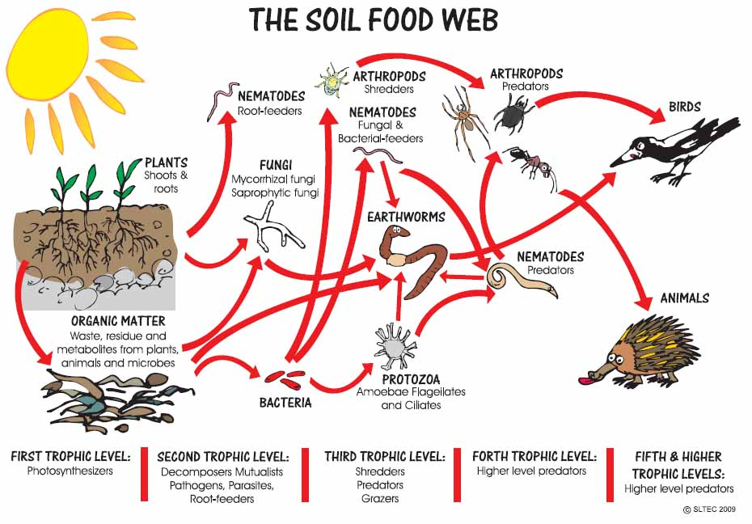

2.Write a paragraph on the relationship between soil food web, plants, organic matter, birds and mammals
● Organic matter is needed by plants in order for nutrients to be sufficient. In addition, organic matter is needed by plants since they need to consume the energy. All birds and mammals are considered to be the consumer, and rely heavily on plants, seeing as their prey either consume plants, or consume other prey, which consumes plants. It relates to the soil food web, since plants are deep rooted in the soil. Additionally, organic matter is found within the soil.
3.Explain the relationship between soil ecosystem succession and soil fertility.
- For primary succession, the soil is originally not there in the beginning seeing as it occurs on a barren land. There is no humus present, seeing as there is no soil. To conclude, not much can be said over whether the soil is fertile or infertile, but based on what is provided, soil is infertile and lacks all the nutrients needed in order to help make plants grow.
- On the other hand, with secondary succession occurs on a land, which has already been previously occupied. Hence, soil would be present and as a result, so will humus. It can be said that the soil would be more fertile during secondary succession, seeing as there are already nutrients laden within the soil, compared to primary succession, where this cannot be said.

Task 5
1.Outline soil conservation measures
- Plant more trees in order to combat growing CO2 emissions and to keep soil healthy
- Terracing to prevent harmful run off
- Contour plowing to prevent soil washing off
- Crop rotation to keep the soil fertile and maintain its structure
- Washing the soil to avoid salinity as well as remove any harmful pesticides
2.Evaluate the soil management strategies of a given commercial farming system and of a given subsistence farming system.
Commercial: North American wheat farms. Typically more developed so are exposed to technology. Use crop rotation as well as washing the soil. Contour plowing is used as well to keep the soil fresh and fertile.
Subsistence: farms in west Africa. Typically smaller and not as advanced to maintain the soil. Crop rotation and planting many crops are the most notable methods of soil conservation
3.Discuss how variant use of soil systems can lead to different degradation and conservation.
- Commercial and subsistence have varying impacts
- Degradation is caused by deforestation, monoculture, over grazing, and urbanization
- Commercial farming has caused soil erosion and degradation due to a focus on output rather than process
- Subsistence typically have conservation as they focus on reusing the soil to feed their families.

