Faisal Eraiqat
Mr. Mangan
IB2 ESS
27 November 2016
6.1 Tasks
Task 1:
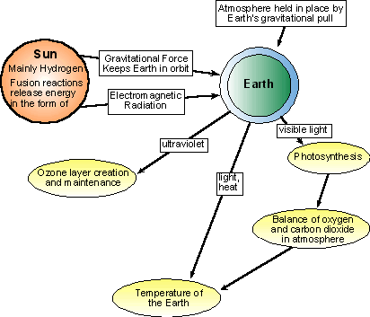

Task 2:
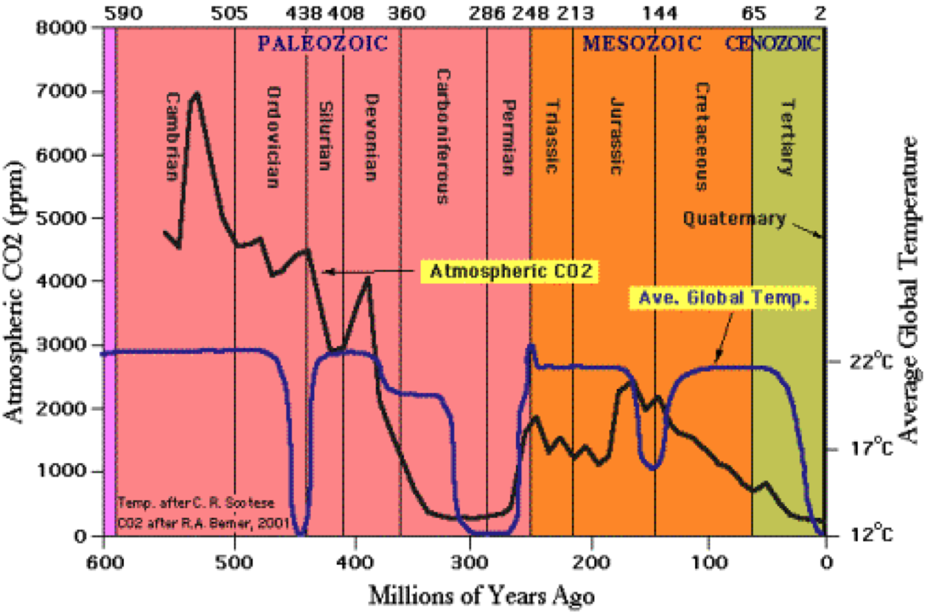
1.What is the relationship between carbon dioxide and temperature in the graph?
- The relationship between carbon dioxide and temperature in the graph is evident since in the beginning, as CO2 increases, the temperature remains stagnant, however for the most part there is no correlation between the two aspects, since it appears to be random.
2.What other factors besides atmospheric carbon may influence Earth temperatures?
- Other factors which influence Earth temperatures are:
  - Methane
  - Water vapor
  - Human activities, which push for climate change.
3.Can we rely on the data collection methods used?
- To an extent, we should be reliant upon data collection methods, as it allows humans to identify the estimated temperature and their changes, however even then it cannot be considered to be as reliable. It is not reliable in the sense, that climate changes constantly and there are too many factors to contribute, that by simply relying on Carbon would make the data presented inaccurate.

