Activity 1:

years | Population | Doubling Time
1804-1927 | 1-2 billion | 123 years
1927-1974 | 2 to 4 billion | 47 years
1974-2024 | 4 to 8 billion | 50 years

Activity 2:

Region | ^{Population}  ¹⁰⁶ | ^{Land}  ^{Area km2 x 106} | Births  10⁶ | Deaths  10⁶ | Crude  Birth Rate | Crude  death rate | Natural  increase rate | Population  Density
World | 6,000 | 131 | 121 | 55.8 | 20.2 | 9.3 | 109 | 45.8
Asia | 3,500 | 31 | 88.2 | 29.4 | 25.2 | 8.4 | 1.68 | 112.9032258
India | 1,000 | 3 | 29 | 10 | 29 | 10 | 1.9 | 333.3333333
Africa | 730 | 29 | 30.7 | 10 | 42.05479452 | 13.69863014 | 2.835616438 | 25.17241379
Tanzania | 30 | 0.9 | 1.3 | 0.4 | 43.33333333 | 13.33333333 | 3 | 33.33333333
Europe | 730 | 22.7 | 8.5 | 8.2 | 11.64383562 | 11.23287671 | 0.04109589 | 32.15859031
Switzerland | 7 | 0.04 | 0.09 | 0.07 | 12.85714286 | 10 | 0.285714286 | 175
N  America | 460 | 21.8 | 9.3 | 3.6 | 20.2173913 | 7.826086957 | 1.239130435 | 21.10091743
USA | 270 | 9.6 | 4.3 | 2.4 | 15.92592593 | 8.888888889 | 0.703703704 | 28.125

Activity 3:

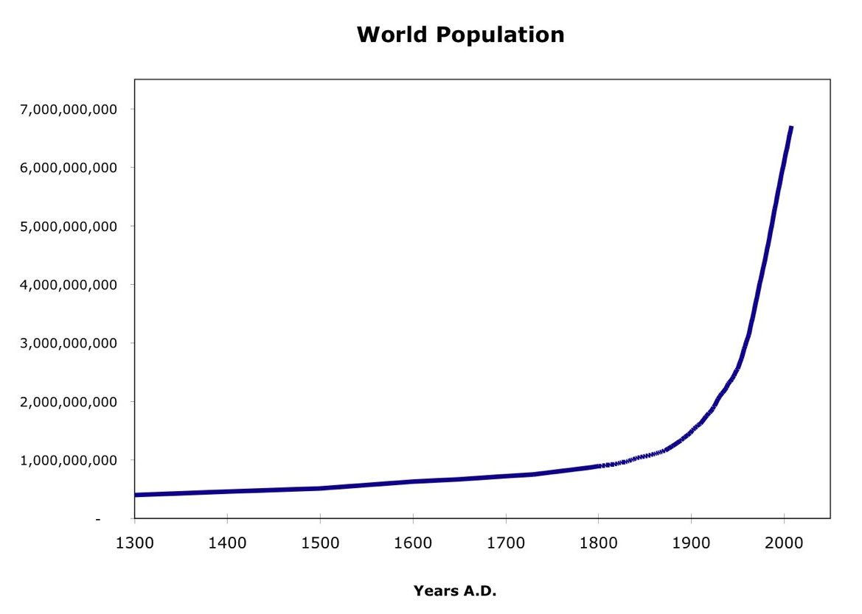

- It has exponentially increased. It has particularly increased since the 18th century, and this could be down to technology. It was steady from the 1300s until the 1700s, where it increased. It looks like a J curve, which is a boom and bust curve.
- 70 years

Date | ppl | doubling | date | ppl | doubling
1500 | 0.5 | 1,500 | 1987 | 5 | 13
1800 | 1 | 300 | 1999 | 6 | 12
1927 | 2 | 127 | 2012 | 7 | 13
1960 | 3 | 33 | 2024 | 8 | 12
1974 | 4 | 14 | 2048 | 9 | 24
- They have significantly decreased and this can be down to technology and encouragement of births, since there is safe options to give birth. Also, more women have access to better health resources, which can permit for more births as opposed to miscarriages.

