Faisal Eraiqat
Mr. Mangan
ESS
12 October 2016
Research Skills
Newfoundland Cod Fishery
- Unsustainable, disaster, many issues, had to end in 1992 due to overfishing
- Gear and boats:
  - Started in late 1400’s, so improved overtime to modernize and meet requirements, but did not develop enough and efficiently to be sustainable
  - “Fairtry” machine. 15 years, over 8 million tons of cod
  - led to overfishing and its eventual collapse
- Detection:
  - Collapsed so no satellite images
  - In Canada, Northwest Atlantic
- Quotas:
  - Current region is at 8143
- Designation of Protected Areas:
  - Eastport Peninsula
  - Leading Tickles
- Restrictions on types and size of gear (mesh size)
  - 67mm mesh size max
Iceland Cod Fishery
- Sustainable, regulated
- Gear and boats
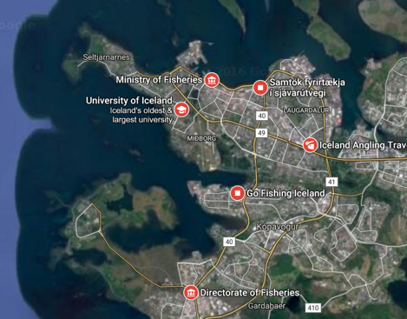
  - Long line, Danish seine, gillnets
- Detection:
- Quotas:
  - On individual vessels, major commercial stocks subject to quotas, depends on size of company and vessel and annual changes
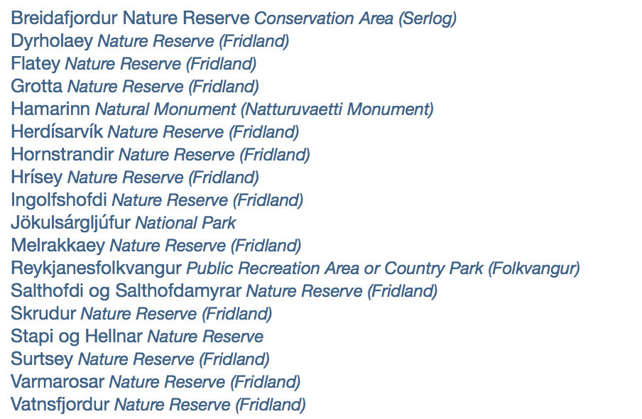
- Protected Areas:
  - Eighteen areas surrounding the island
- Restrictions on mesh size
  - 130-155 mm (trawl fisheries)
  - 135-155 mm (Danish Seine)
  - 140-155 mm (nets)

