Faisal Eraiqat
Mr. Mangan
ESS SL
10 January 2017
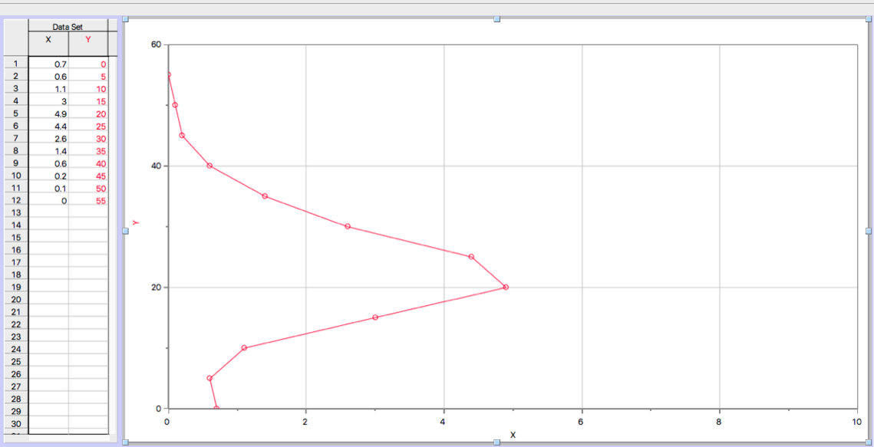
Ozone Layer Lab Question

- Greatest concentration of ozone:
20 km
- Layer with most ozone:
Stratosphere
- Why is ozone important for life:
Ozone layer protects the Earth from harmful radiation and UV light by limiting it from entering the troposphere. Plankton and vegetation cannot live with high amounts of UV, so the ozone protects them thus allowing fir vegetation to grow and allow life to flourish.
- Describe how ozone was put in danger:
CFCs and other greenhouse gasses are being released into the atmosphere, causing the ozone to get thinner and speeds up the breakdown of oxygen. The chlorine gasses from the greenhouse gasses attack the ozone, so less oxygen to form and less to protect the Earth from UV.
- Human reaction:
Governments created the UN Montreal Protocol. Forcing to use ozone-friendly chemicals to reduce the amount of CFCs being released. International Day for the Preservation of the Ozone Layer.
- Describe how the idea of dynamic equilibrium can be applied to the ozone layer:
The chlorine that goes up creates a misbalance as it counteracts the ozone’s impact on UV, allowing the radiation to easily enter the Earth. Previously, the ozone would naturally form and break down but now the reaction is sped up and less ozone is present.

