Faisal Eraiqat and Atiqah Mohd Azhar
Mr. Mangan
IB ESS
2 May 2016
Research Skills
- Physical barriers
  - Volcanoes
  - Earthquakes
  - Tsunamis
  - Pollution
  - Forest Fire
Examples: Pompeii, Mountain Range
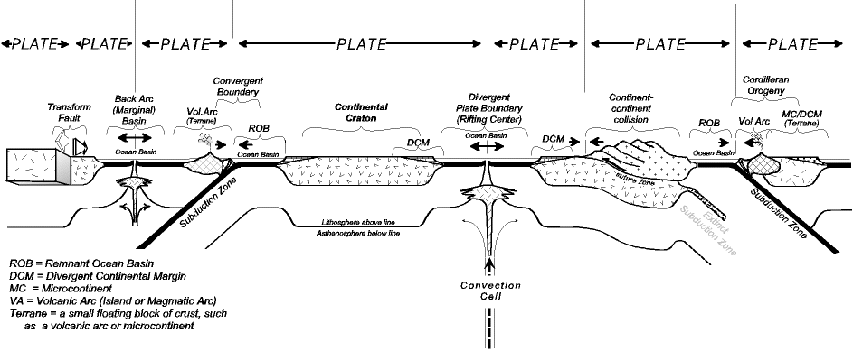
- Plate tectonics is the theory that the outer rigid layer of the earth (the lithosphere) is divided into a couple of dozen "plates" that move around across the earth's surface relative to each other, like slabs of ice on a lake.

- It changes because a new environment is made, and there is new vegetation, which forces species to adapt. The more adaptation there is, the more it is evident that evolution occurs.

