Topic 6 Reading questions
6.1 Introduction to the atmosphere AND 6.2 Stratospheric Ozone
Outline the overall structure and composition of the atmosphere:
- Made up of several gases: Nitrogen, Oxygen and others like CO2 that are trace elements
- Transfers and transformations with heat being moved around by gaseous storages
- Controls temperature and UV light entering
- Human activity harming it such as with methane and pollution trapping more heat and weakening it

Briefly summarize the greenhouse effect:
- The greenhouse effect is the when the sun’s heat is trapped within the atmosphere. This is from the buildup of excessive greenhouse gases, which has led to an excess in greenhouse effect. This excess has been dubbed the “enhanced greenhouse effect”.
Sketch figures 6.5 and 6.11:
Figure 6.5
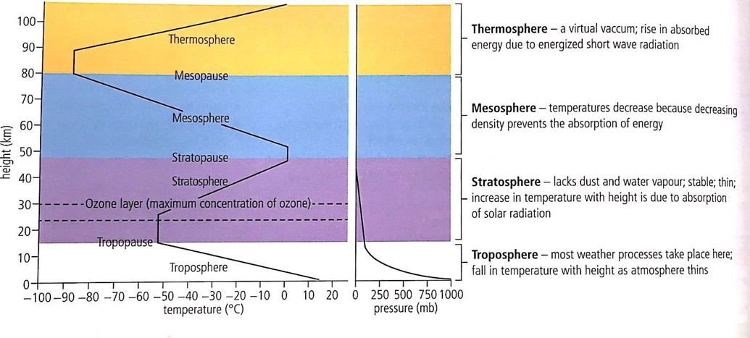

Figure 6.11
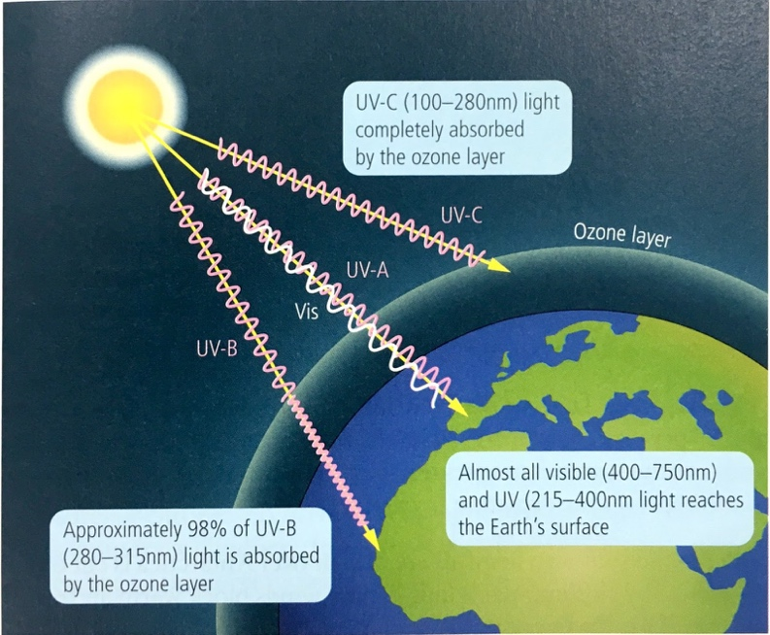

Distinguish between good and bad ozone:
A good ozone, refers to the ozone hole, which is located in the stratosphere, and is considered to be good, as it assists in shielding life on earth from the harmful UV rays of the sun. However, a bad ozone layer refers to the ground-level layer, which is an air pollutant, which is harmful as it mostly consists of urban smog. Bad ozone is usually referred to as the tropospheric ozone, while a good ozone is called a stratospheric ozone.
Explain how the ozone layer is an example of dynamic equilibrium:
The ozone layer is considered to be an example of a dynamic equilibrium since the ozone formation and destruction both show individual molecules changing constantly and quickly, however the overall concentration of molecules do not appear to change.
Describe the role of ozone in the absorption of UV radiation:
- In Stratosphere
- Shields the Earth
- Oxygen rising reacts with the sunlight to form the ozone
- Produced by sunlight and destroyed by nitrogen oxides
- The oxygen absorbs the majority of it
- The more O3, the more UV gets absorbed that less enters the Earth
- Ultraviolet radiation is absorbed during the formation and destruction of ozone from oxygen
List the effects of UV radiation on living things:
- Mammals are prone to cancer
- Aquatic animals are more vulnerable
- Experiments on food crops have shown lower yields for several key crops such as rice, soybeans and sorghum.
- Sunburn
- Suppression of immune system

What does ODS stand for:
ODS stands for Ozone Depleting Substances.
State an example of a halogenated organic gas (other than CFCs) AND its source:
Trichloroethylene is an example, and its source is by mixing several substances. On example of its source is ethylene. To get the reaction, the most commonly used catalyst is a mixture of potassium chloride and aluminum chloride.

Explain how UV radiation reacts with halogenated organic gases such as CFCs:
- Creates holes in the ozone
- Creates an imbalance as more O3 is being destroyed than being generated
- Chlorine compounds could rise up from human activities, which then transforms to chlorine atoms. Sunlight then makes the atoms destroy the ozone.

State the two effects the reaction above has on ozone:
- Skin cancer
- Eye damages such as cataracts
Explain how CFCs' stability affects the atmosphere:
- Break down of the oxygen in the ozone, weakens the atmosphere and increases temperature
- Global warming with more greenhouse gases being released
- Makes the atmosphere vulnerable and the gases traps the UV/heat inside the planet
- Holes in the Ozone
- Constant output of CFC from human activity

