Layers of the Atmosphere Webquest

Use the following links to fill out the worksheet on the back of this page.

http://www.vtaide.com/png/atmosphere.htm
http://www.enchantedlearning.com/subjects/astronomy/planets/earth/Atmosphere.shtml

When you are finished with the worksheet, play these games to check your mad skillz:

http://www.purposegames.com/game/899 - keep playing until you beat your high score!
http://www.brainpop.com/science/earthsystem/earthsatmosphere/quiz/ - username is tmstrojans, password is green. Take the review quiz for Earth’s Atmosphere. (DON’T WATCH THE VIDEO.)

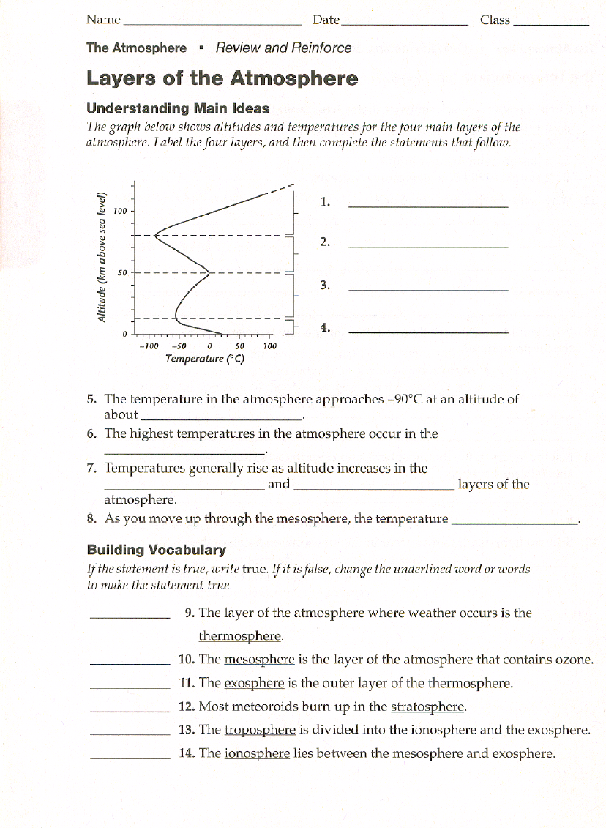
F, troposphere

F, Stratosphere

True
F, Mesosphere

F, thermosphere

True
decreases
Stratosphere and thermosphere
Thermosphere
80 km
Thermosphere

Mesosphere

Stratosphere

Troposphere
Faisal Eraiqat

