Faisal Eraiqat

Worksheet 3.3: Mass extinction events

Present and past extinctions
Examine evidence of mass extinctions in the past and compare and contrast the possible cause of these to present-day extinctions. The time frame of these periods of extinction should be considered.
Questions
Use the internet to answer the following questions.
1 How many mass extinctions have there been in the past? [1 mark]
Five mass extinctions
2 Produce a timeline showing these extinctions in terms of geological time (see the example below). [5 marks]
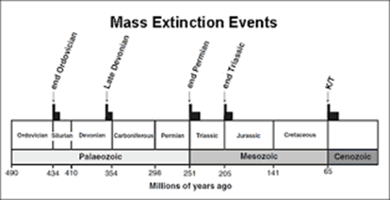

3 What percentage of the total number of species on Earth went extinct in each of these ‘great extinctions’? [2 marks]
Ordovician-Silurian extinction: 85% of all Ordovician species
Devonian: 70-80% of all animals present during that time period
Permian: 90% of marine species and 70% of terrestrial species died out
Triassic: 76% of all marine and terrestrial species and about 110% of all taxonomic families
K/T: approximately 80% of all species of animals at or very close to the boundary between the Cretaceous and Paleogene periods
4 How many species do scientists believe are on Earth at the moment? Can we know for sure? [2 marks]
About 8.7 million (6.5 on land, 2.2 in oceans); no as there are many places in the planet that are home to species we do not have a means of access to like the deep bottom of an ocean.
5 What do scientists mean by the ‘sixth great extinction’? What is causing it? [1 mark]
Humans are causing the next mass extinction, and is underway, with the most species die-offs since dinosaurs
6 What is the current estimated rate of extinction? What are the problems with such estimates? [2 marks]
current rate is about 100 extinctions per million species per year, and can rise to 10,000 times higher. Bad as it shows how bad the current situation is.
7 What caused the extinctions in the past? How does this compare with what is causing current extinctions? [2 marks]
They were from natural causes or phenomenon that eliminated species. Currently, they are man made extinctions, rather than naturally as part of natural selecrtion.
8 Over what time periods have the mass extinctions taken place? What is the average time period between mass extinctions? [2 marks]
Very short time periods. Most recent was during the Cretaceous-Paleogene and the most severe during the Permian period. They are usually tens of millions of years apart, with the last one 66 million years ago.
9 Over what time-frame is the current mass extinction believed to be happening compared to past mass extinctions? [2 marks]
The Neogene time period and is over a longer period of time as it is not an instant extinction, but a growing one.
10 How long, on average, did it take the Earth to recover from past mass extinction events? [1 mark]
5 to 10 million years with worst case scenario being 15 to 30 million years

Figure 1 Mass extinction events

Worksheet 3.5: Threats to biodiversity

HIPPO
There are many different threats that can lead to species becoming endangered. HIPPO is a mnemonic that helps to remember the various threats that biodiversity faces, with each letter representing a different threat.
Activity
Which threat is represented by each of the following photos? Make notes beside each picture, describing the threats shown. What do you think the letters H, I, P, P and O stand for (fill in the gaps below)? Clues are given for the first two photos.

HUNTING
Shown in the pictures:
- mobile phone
- banana
- fragments of coral
- aluminium cans
- logging operations.

Notes
Destruction, human interference, habitat destruction did not fit so hunting is the best alternative, showing the human interference leading to death
_______________________________________
_______________________________________
_______________________________________
_______________________________________
_______________________________________
INVASIVE SPECIES
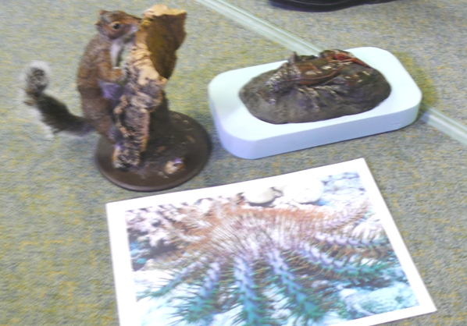
Shown in the picture:
- grey squirrel
- red-clawed crayfish
- crown of thorns starfish.

Notes
Squirrel invading a crayfish and starfish
_______________________________________
_______________________________________
_______________________________________
_______________________________________
_______________________________________

POLLUTION
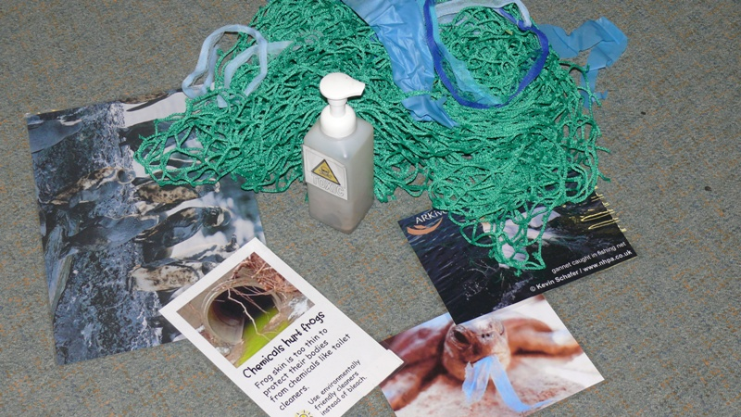

Notes
toxic bottle, chemicals, oil, turtle stuck, garbage
_______________________________________
_______________________________________
_______________________________________
_______________________________________
_______________________________________

POPULATION GROWTH
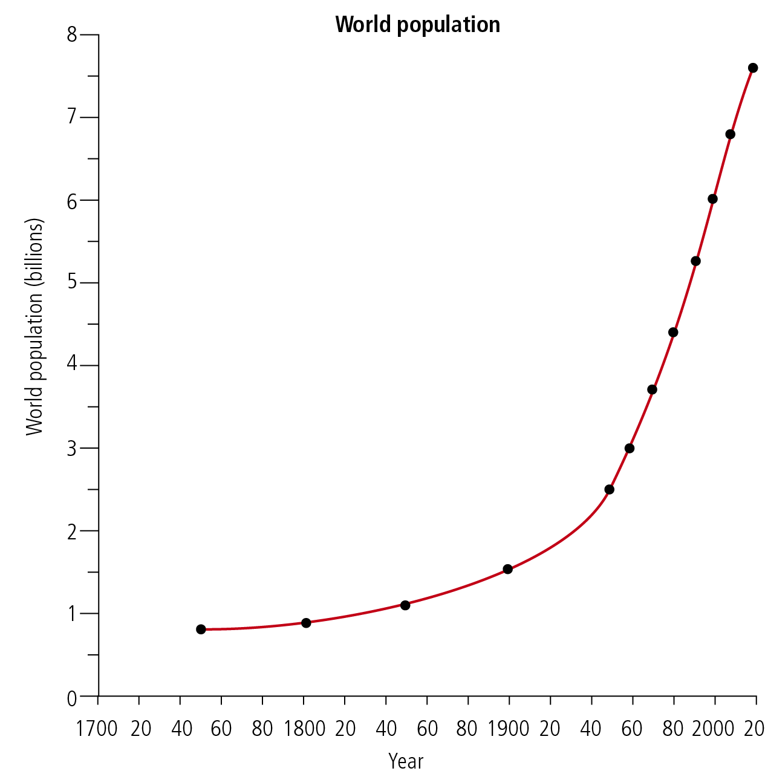
Notes
Population rising significantly over time
_______________________________________
_______________________________________
_______________________________________
_______________________________________
_______________________________________

OVERHARVEST
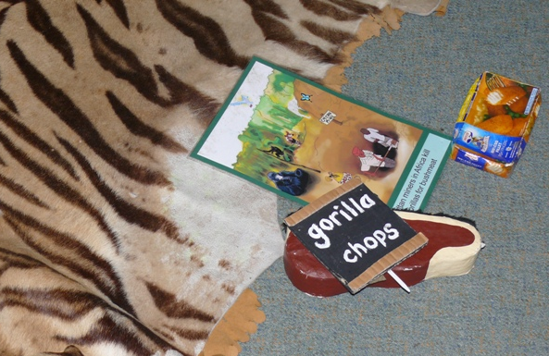

Notes
Fur carpet, gorilla meat, food, digging a hole destroying the habitat
_______________________________________
_______________________________________
_______________________________________
_______________________________________
_______________________________________

Worksheet 3.6: Aliens reported everywhere

Native and alien species
The UK’s flora and fauna include many species that are non-native to the British Isles. Some species are deliberately introduced, such as the rabbit from Normandy and the buddleia from China. Others come in as unwanted immigrants – aliens – unnoticed and unannounced. Once in the country, they may have such a large impact that they lead to the decline of native species. The success of the grey squirrel at the expense of the red squirrel is a very good example. The latter is now restricted to just two locations in the UK, having once been widespread over much of the country.

According to the Environment Agency, alien species of plants and animals are costing the UK economy approximately £1.7 billion every year. The 10 ‘most wanted’ invasive species include the ‘killer’ shrimp, water primrose, floating pennywort, North American signal crayfish, top mouth gudgeon, giant hogweed, Japanese knotweed, Himalayan balsam, mink, and Chinese mitten crab.

The decline of white-clawed crayfish
The white-clawed crayfish is native to Britain but 70% of the population has been wiped out from the southwest, and it has been given priority status in the UK’s Biodiversity Action Plan. The North American signal crayfish was introduced in the 1970s for the fishery industry. However, this aggressive species out-competes the white-clawed crayfish and the population of the latter has been decimated. The crayfish plague is carried by the signal crayfish and can wipe out populations of white-clawed crayfish in a few weeks. The disease can be carried from stream to stream via boots, fishing equipment and recording equipment. In addition, habitat loss and declining water quality have restricted the number of sites in which the white-clawed crayfish can survive.

The Southwest Crayfish Project
The Southwest Crayfish Project works in association with the Bristol Conservation and Science Foundation in attempting to preserve the white-clawed crayfish in a number of ways such as:
- by increasing awareness about how the disease can be transmitted and the problems facing native crayfish
- by introducing a breeding programme and releasing crayfish back into the wild
by moving ‘at risk’ populations to safe areas.

Zebra mussels – costing a fortune
Zebra mussels, originally from the Black Sea, are costing Thames Water up to £1 million a year in their efforts to keep pipes and filters clear of the molluscs. The mussels are believed to have originally come to Britain in the ballast water of ships traveling between the Black Sea and Britain.
According to some sources, zebra mussels have no natural predators in the UK. However, Wikipedia claims that crayfish are predators of the zebra mussels.
In Walthamstow, London, over 800 tonnes of zebra mussels were removed from pipes. Thames Water is using biobullets to combat the mussels. These fat-coated pellets are especially palatable to the mussels but contain a chemical that is deadly to them while being safe for humans and other creatures. For further information on biobullets, go to www.pearsonhotlinks.com, enter the book title or ISBN, and click on ‘Worksheet 3.6’.

Oxford ragwort and buddleia
The Oxford ragwort escaped from Oxford’s Botanical Gardens in 1794. By 1867 it had reached London, some 80 km away. Now it has colonized most lowlands areas in the British Isles. The cinnabar moth, a large common red moth, produces larvae that will only eat ragwort. Because the Oxford ragwort has become such a colonizer, even in the hostile inner city, the cinnabar has been encouraged to become an urbanite as well.
A number of plants have been imported for their medicinal uses or their aesthetic appeal. Buddleia was brought from western China in around 1890. In its early stages of growth it does not compete well with grass, but in cities and on walls where little else grows, it does extraordinarily well. It can be seen at the top of derelict buildings and peering up from basement window wells. It is a plant that attracts butterflies. The caterpillars of several butterflies, including the tortoiseshell and the red admiral, feed on the common nettle. These grow alongside buddleia, all over wasteland in cities.
Questions
1 What is an invasive species? [2 marks]
Is when another plant or animal not native to a location or habitat goes to that habitat and disrupt the natural order, affecting the food chain, environment, health, and can lead to the endangerment of other species.
2 How do invasive species get to an area? [3 marks]
some are deliberately introduced such as rabbits from Normandy, some are unwanted immigrants or aliens. They can move as their habitat is destroyed and they seek new ones, or weather causes them to move, or humans move them for trading to deal with a problem.
3 What are the impacts of invasive species? [3 marks]
destruction of environments, endangering species, changing the habitat, competition, habitat changes, disrupting natural order, changing food chains, spreading disease.
4 To what extent is it possible to manage invasive species? [2 marks]
there are programs dedicated to spreading awareness, protections sites are made to limit the impacts, illegal to bring in certain species in certain areas, captivity sites, community support, but anything natural is difficult and hard to manage.

