Worksheet 3.10: Big ideas in conservation

The holistic approach
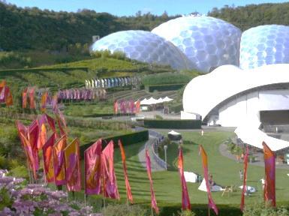
Conservation works best when a holistic approach is taken.
A holistic approach means that the focus is not only on the conservation of ecosystems and wildlife, but also on education, research, local and government involvement, and on initiatives that raise awareness with the public. By getting the public involved, not only is the awareness of conservation issues improved, but vital money is raised to support essential conservation programmes.
The bigger the idea in conservation, the more likely it is to attract interest. Without public awareness and funding, many, if not all conservation projects would either fail to be sustained, or never get off the ground in the first place. By providing ‘big ideas’ they act to stimulate interest and excitement in conservation and energise people to work together to protect the Earth’s irreplaceable biodiversity. ‘Big ideas’ can encapsulate any of the following:
The Eden Project – an example of a Big Idea.
- the scale at which the conservation initiative operates (i.e. large and wide-ranging)
- the vision behind the scheme
- ideas that are ahead of their time
alternative approaches to conservation that catch the public’s interest.
Big ideas also provide the opportunity for commercial companies to support conservation. It is often such companies that have the necessary financial support and public-relations expertise to enable them to have a significant influence on conservation initiatives. If both the public and big business can get excited about conservation, and can see how their contribution will have a tangible impact, they are more likely to get involved through participation and financial support. Public interfaces for conservation may not be directly located in the areas that they are helping to conserve, but their activities and educational role may play a significant role in supporting conservation initiatives elsewhere.
This worksheet explores two organizations that have big ideas at their heart, and the role they play in conservation both locally and globally.

Eden Project
The Eden Project is one of the biggest visitor attractions in the UK. It is near St Austell in Cornwall, south-west England. Its primary aim is to promote an understanding of the relationship between plants, people and resources, and to encourage sustainable development. Through its innovative design it has showcased both architecture and landscape design. The main features of the attraction are two giant domes that house different biomes. The domes consist of hundreds of hexagonal and pentagonal inflated plastic cells supported by steel frames. In one, there is a rainforest biome and in the other, a Mediterranean biome. Both are technically and visually impressive and demonstrate to visitors that big ideas are central to the Eden Project.
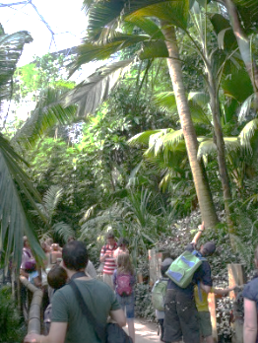
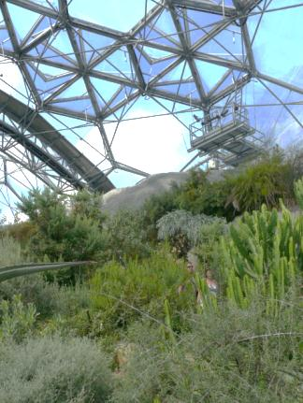

The Rainforest biome. The Mediterranean biome.

There is also an innovative education centre (The Core), the roof of which follows the Fibonacci pattern seen in many natural objects such as pine-cones and shells. At all points in a visit to the Eden Project, visitors are informed about why plants are essential for humanity’s existence and how we rely on them in very many different ways.
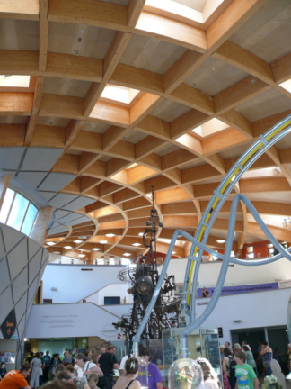
The roof follows the Fibonacci pattern.

What’s at Eden?
The world’s largest greenhouses containing two biomes: one with the largest rainforest in captivity and the other with Mediterranean plants. A desert biome is planned.
Ground-breaking architecture and buildings.
Impressive garden displays that have seasonal plants that provide public interest throughout the year.
Innovative art and music. The Eden Sessions feature leading musicians from around the world.
An education centre with displays and demonstrations that inspire all ages.
Local sourced and fairly traded food in all restaurants and cafes.
A rainforest lookout and canopy walkway though the tops of the trees in the rainforest biome.
Living examples of regeneration and sustainable living in the form of plants and their products.

The Eden Project provides an excellent example of what can be done if a group of people have a big idea, and the vision, stamina, and strength of purpose to carry it through. The project was started by Tim Smit and a small group of entrepreneurs. The same group had been involved with restoring the Lost Gardens of Heligan (page 4) a few years before the Eden Project began. Funding was sought from grants, loans and sponsorship arrangements: this funding provided the 50 per cent match-funding needed to secure a Millennium Commission grant. The combined finances enabled the project to begin in earnest in 2000. The Eden Project opened fully to the public in March 2001.
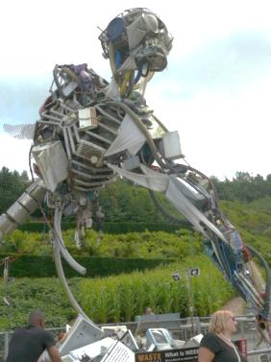
The Project is located in a disused china-clay pit – all the soil and plants needed for the biomes and surrounding grounds had to be brought into the pit. The soil was created by the Eden Project team with support from Reading University. An ingenious water system was created to pump water, which would otherwise flood the pit, and recycle it throughout the Eden Project. The project is therefore a symbol of regeneration, recycling, and renewal – themes it actively promotes through its displays and educational material (e.g. the WEEE man made from recycled waste; see page 422 of the textbook).
The WEEE man
Food in all restaurants and cafes is locally sourced and fairly traded.
The Eden Project is involved in many programmes, including work on climate and environment, people and learning, and places and regeneration. Read about these initiatives here.

The Lost Gardens of Heligan
Heligan House is a large stately house located near the town of Mevagissey, south-west England. It was home to the Tremayne family, who bought the land in the 16th century. Over time, the family developed formal gardens around the house – some of the best to be found in the UK. Before the First World War, the gardens were maintained by 22 men. Many of these gardeners served in the war, and only eight survived. This meant that the gardens were difficult to maintain. Then, in the 1920s, the owner moved abroad and the house was rented out. In the 1970s the house was sold, but not the gardens, which were by now overgrown and derelict. Then, a descendent of the Tremayne family, John Willis, explored the estate around the house, and introduced Tim Smit to the overgrown gardens. Smit and Willis were inspired by a motto carved into a limestone wall in a building in the gardens: ‘Don’t come here to sleep or slumber’, with the garden workers' names signed underneath with the date, August 1914.
Smit and a group of fellow enthusiasts decided to restore the gardens to their former glory, and eventually leased them from the Tremayne family. They were opened to the public in 1992 as the Lost Gardens of Heligan.
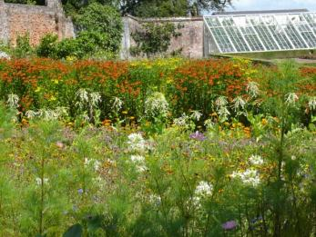
As well as restoring the formal gardens, the Heligan team also restored, and continues to work on, much of the wider park estate including ancient forests and wild meadows. The ancient pastures, woodland, ponds, and lakes are being sustainably managed to maximise biodiversity. The management of the wider estate is preserving valuable habitats, and maintaining their historic positions within the Heligan Estate.
The Flower Garden, with restored greenhouse
Education is an essential element of a visit to the Lost Gardens, with activities for children organized to encourage their appreciation and understanding of wildlife.
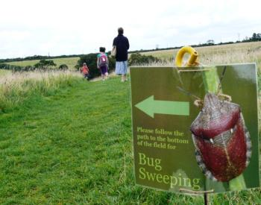
Through bringing the gardens of Heligan back to life came the seeds of an idea that grew into the Eden Project. The thinking of the Heligan team was: if money could be raised and public interest generated in a garden restoration project, then why not develop a project that shows off the power and potential of plants using the largest greenhouses on the planet?
Children’s activities at Heligan
The ideal spot was found near to Heligan, in a china clay pit that was about to be decommissioned and closed down. The warmer temperatures in England’s south-west, and the local expertise that had been built up in the Lost Gardens of Heligan, provided the perfect backdrop for developing the Eden Project.

The Lost Gardens represent a ‘big idea’ – that the abandoned gardens and park estate could be restored, and even improved, while enhancing the biodiversity of the area by promoting the conservation of artificial and natural habitats.
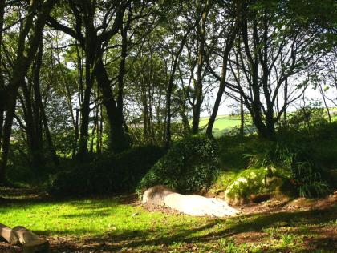
Creative art is promoted at Heligan. The estate land contains several unique and striking sculptures that blend in perfectly with the woodland surroundings, and encapsulate what Heligan is all about; for example, the Mud Maid and the Heligan Barn Owl.
The Mud Maid
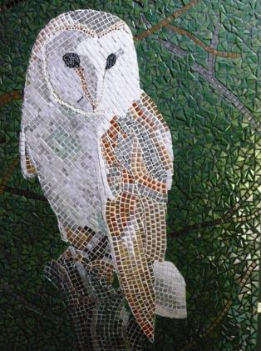
The Heligan Barn Owl mosaic is made from recycled glass and tiles.

Photos and a film of the gardens prior to restoration show the magnitude of the task the restoration team faced.
Both the Eden Project and the Lost Gardens of Heligan are good examples of how big ideas can leave a lasting positive legacy, and why holistic approaches to conservation prove to be the most successful.

Further reading
For further information and useful resources to support this worksheet, go to www.pearsonhotlinks.com, enter the book title or ISBN, and click on ‘Worksheet 3.10’.
Activities
- Summarize why the Eden Project and the Lost Gardens of Heligan have been successful in supporting local and global conservation.
Been able to increase awareness and gain international support for their respective causes. Eden’s domes were successful and cooperated with locals and showed their sustainable nature. The Gardens one restored formal gardens and made improvements to the park, and resorted the area.
2 Research a conservation initiative within your country that is based on a ‘big idea’. Produce a presentation about it to show to the rest of your class. Aim to cover the following points:
- What ‘big idea’ does it encapsulate? Why do you consider this to be a big idea?
- What aspects of conservation does it cover?
- What evidence can you find to show whether it is successful at fulfilling its aims?
- Is it an example of holistic conservation? If so, why?
Aichi Target 11 commits CBD Parties to conserving 17% of the terrestrial surface of the earth, especially “areas of particular importance for biodiversity” through “well-connected” systems of protected areas or “other effective area-based conservation measures” (OECMs). This project will assess the degree of connectivity existing currently, with a focus on one taxon (birds) and one region (Africa), and by so doing, enabling better assessment of the feasibility of extending globally. For bird species, this project will assess connectivity between protected areas (PAs), Key Biodiversity Areas (KBAs), as the largest systematically identified network of areas of particular importance for biodiversity, and Indigenous and Community Conserved Areas (ICCAs), as one type of OECM. Developing this connectivity measure has strong relevance to ecological science: although we know that many species can persist in fragmented landscapes, other species are less tolerant (i.e. species with low dispersal abilities) and tend to decline in fragmented and degraded landscape areas.
This project will identify both protected and unprotected habitat patches that are of particular importance to the maintenance of populations of assemblages of forest-dependent birds and that are also under severe threat from recent and potential future land-use changes. This project will also highlight species for which improved connectivity of habitat patches is a priority for their conservation.
Aichi Target 11 commits the Convention on Biological Diversity (CBD) Parties to conserving 17% of the terrestrial surface of the earth, especially “areas of particular importance for biodiversity” through “well-connected” systems of protected areas. This project aims to assess the degree of connectivity of protected and unprotected habitat patches for forest dependent birds in Africa, highlighting species and locations for which connectivity is a priority for their conservation. Project developments and findings will highlight the potential to expand this approach globally, to extend to other taxa and to contribute to measurement of progress against Aichi Target 11.

