Worksheet 3.7: Conservation organizations

Different roles for different needs
Environmental organizations fall into two categories depending on how they operate and are funded. Governmental organizations (GOs) may be intergovernmental (IGO) or part of a national government; non-governmental organizations (NGOs) are set up by environmentalists independent of government, and may be international or local, and funded through interested independent parties or subscriptions.
You are going to compare and contrast the role and activities of intergovernmental and non-governmental organizations in preserving and restoring ecosystems and biodiversity. You are also going to consider recent international conventions on biodiversity (for example, conventions signed at the Rio Earth Summit (1992) and subsequent updates).
Environmental organizations operate in different ways. In their dealings with people, some work at government level, while others work with local people ‘in the field’. To bring about change, some work conservatively by careful negotiation, while others are more radical and draw attention to issues using the media.
Now read about the UNEP (United Nations Environment Programme).
Look also at the UNEP Organizational Profile.
Questions
1 What are non-governmental organizations? List any you can find involved with conservation. [2 marks]
private or public, non profit, organizations made by people, working locally or internationally. Such as: African Wildlife Foundation
2 What are intergovernmental organizations? List any you can find involved with conservation. [2 marks]
body made by a treaty, 2 or more nations, wokrign for the good of a common interest, such as: GEF, global environment facility
3 Place the organizations you listed on Figure 1 and add others that you know of locally and nationally. [3 marks]
GOVT: GEF, IPCC, IUCN
Radical: INBAR African wildlife foundation
Field: ACAP, Hnuti DUHA
Conservative: UNEP
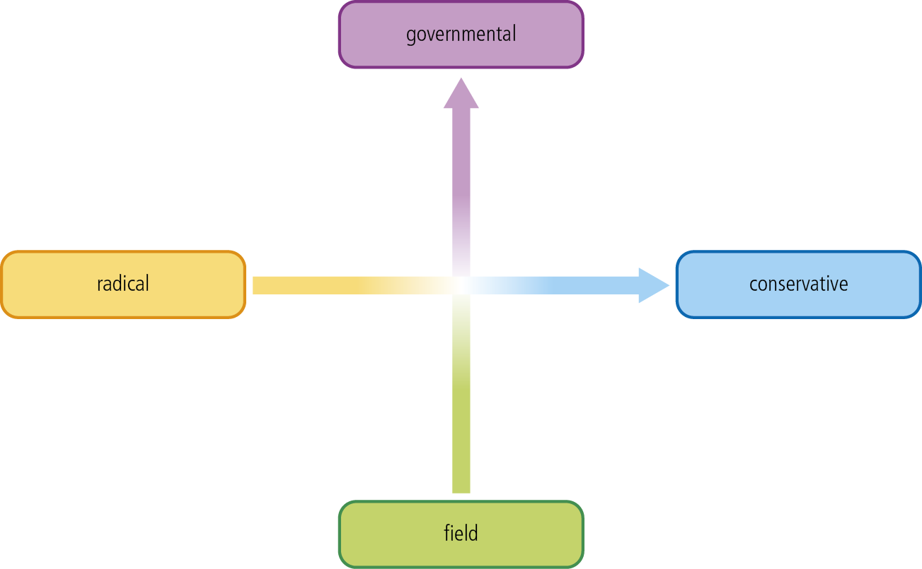
Figure 1
4 Use the table below to compare and contrast UNEP (an IGO) and Greenpeace (an NGO). [8 marks]
 | UNEP – an IGO | Greenpeace – an NGO
Use of media | News, websites, government based, positive image, less public | Website, commercials, more public, negative image
Speed of response | Part of large group so slow | Independent, quick
Political pressures | Good relationship with government, international, politician support | Protests, non government, international, meets with others to promote
Public image | Positive | True/realistic, maybe negative
Legislation | Protection laws and acts | No bills or laws
Agenda | Improve quality of life, encourage environmental care | Expose issues, force solutions
Funding | UN budget, environmental fund | Donations, no government money
Extent of geographical influence | International and regional | International and regional

5 What is the mission statement of UNEP? [1 mark]
“To provide leadership and encourage partnership in caring for the environment by inspiring, informing, and enabling nations and peoples to improve their quality of life without compromising that of future generations.”

6 When was UNEP formed? [1 mark]
5 June 1972
7 What are UNEP’s responsibilities? [3 marks]
monitor global environment, helping environment, spread awareness
8 What are UNEP’s priority areas? [2 marks]
Environmental government, Harmful substances and hazardous waste, Resource efficiency, Climate Change, Ecosystem management, Disasters and conflicts
9 What is the World Conservation Strategy (WCS)? Who set it up and why? [3 marks]
A strategy launched (1980) by the IUCN and WWF to help nations protect ecosystems.
10 What are the main objectives of the WCS? [3 marks]
maintain ecological processes, preserve genetic diversity, sustainability
11 When planning conservation strategies, certain arguments are likely to be more influential than others. Which arguments do the WCS focus on, and why? [3 marks]
living resource conservation is a limited sector, failure to integrate conservation, process that is inflexible, lack of capacity and support failure to deliver
12 What were the aims of the ‘Earth Summit’ of 1992? [3 marks]
build from the Brudtland Report, respond to environmental issues such as climate change and biodiversity.
13 What is Agenda 21? [1 mark]
voluntary action plan from the UN regarding sustainable development
14 Why is it called Agenda 21? [1 mark]
21st century agenda from the UN
15 What is Local Agenda 21 (LA21)? Are there any LA21 programmes in your local area? [4 marks]
A Local Agenda 21 is the strategy and action program for implementing sustainable development at a local level. There are no LA21 in my local area.

