Worksheet 3.9: Holistic approach to conservation

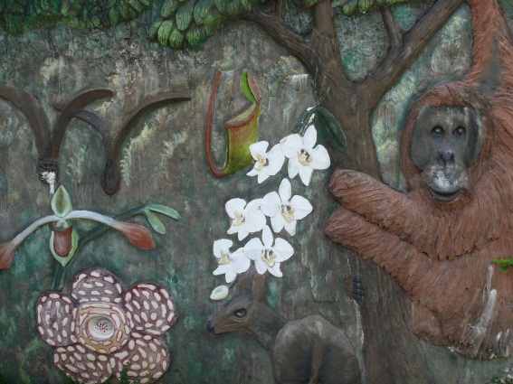
Sepilok, Malaysian Borneo
Detail from mural outside the Rainforest Discovery Centre, Sepilok
Tropical rainforest is one of the most biodiverse and complex ecosystems on Earth (pages 104–06 of the textbook). Its wealth of natural resources also makes it subject to external threats, in particular timber extraction (logging). The location of rainforest also makes it prone to land clearance for crops such as oil palm (pages 174–75 of the textbook). The conservation of tropical forest is therefore of great urgency, because without it, significant areas of rainforest and the animals and plants they contain will disappear (pages 173–75 of the textbook).
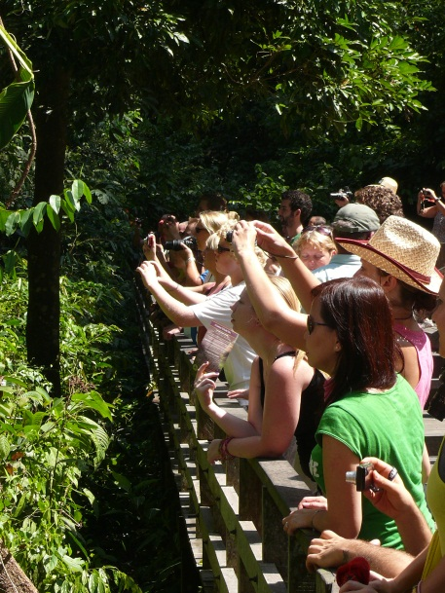
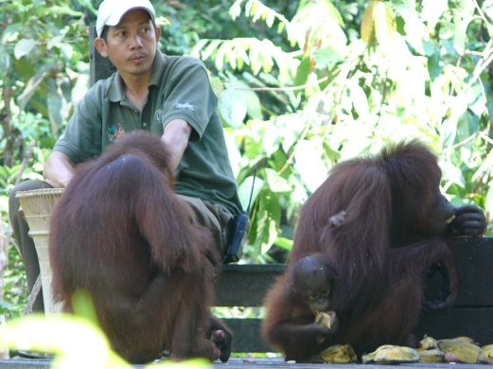
The Kabili–Sepilok forest reserve is 4300 hectares of lowland rainforest on the eastern coast of Sabah, Malaysian Borneo, near the city of Sandakan. The forest reserve is named after two rivers that flow through the reserve and feed into Sandakan bay. The forest is rich in dipterocarp trees (hardwood species) and contains a wealth of natural wildlife, including orang-utans, leaf monkeys and gibbons. In 1964, an orang-utan rehabilitation centre was set up in Sepilok, under the administration of the Sabah Wildlife Department, to rehabilitate orphaned orang-utans that had been taken from their parents through poaching and illegal trade. The orang-utans are trained to survive in the wild and are released once the rehabilitation is completed. The centre now has more than 37 staff, including a Wildlife Officer who is also officer-in-charge of the centre, a veterinary doctor, wildlife rangers and general workers. The centre has a reception centre, information centre, offices for wildlife staff, an animal clinic, and a quarantine area. The centre has grown into a major international tourist attraction, focussed on public education, research, and conservation. Visitors are restricted to walkways and areas where the orang-utans are fed at feeding platforms. Sepilok has stimulated a greater local and international awareness of the protection laws for endangered species, and the centre has resulted in an increase in detection and confiscation of illegally held captive animals.
Tourists watching orang-utans on the feeding platform in the Sepilok reserve.
Feeding platform for orphaned
orang-utans in the Sepilok reserve.

Rainforest Discovery Centre
The Rainforest Discovery Centre (RDC) provides a venue for environmental conservation adjacent to the Sepilok forest reserve, and a short distance away from the orang-utan centre. The Centre is managed by the Sabah Forestry Department as part of their outreach programme. Although the RDC’s main purpose is to act as an environmental education centre for students and teachers, it has attracted tourists since 1996, when it opened its doors to the public. An exhibition hall containing more than 40 interpretive posters explains the ecology and value of the forest, and animal and plant specimens. The educational value of the RDC is further enhanced by rainforest discovery trails highlighting special or interesting aspects of the forest. The RDC aims to increase public awareness and appreciation of the importance of rainforest conservation, and the sustainable use of forest resources. A 147-metre-long treetop walkway enables access to the upper reaches of the forest, and superb views across the reserve. The walkway is used by birdwatchers to view the 250 species of bird found at Sepilok, including the endemic Bornean bristleheads, hornbills, pitas, broadbills and kingfishers.
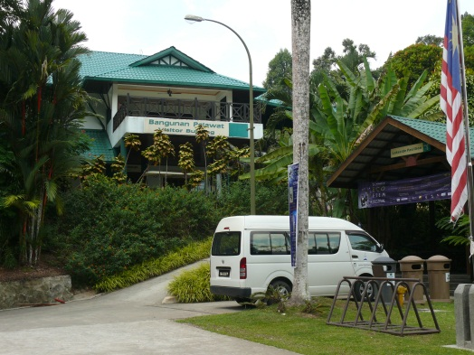
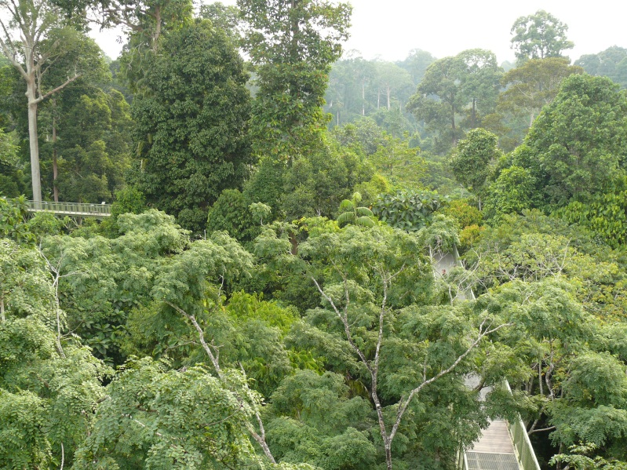

Rainforest Discovery Centre at Sepilok The steel walkway through the forest canopy at the RDC

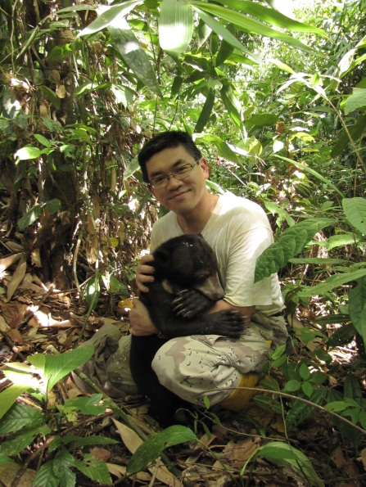
Bornean Sun Bear Conservation Centre
Researcher and conservationist Siew Te Wong started the Bornean Sun Bear Conservation Centre (BSBCC) in 2008. Sun bears (Helarctos malayanus) live in the forests of South-East Asia and it is thought that their population has declined by 30 per cent in the last 30 years. Logging, forest clearance and habitat degradation are all factors that have affected population numbers. Sun bears have also been illegally hunted for body parts, largely for traditional medicine (page 173 of the textbook). The sun bear has been listed on CITES Appendix I (page 200 of the textbook) since 1979.

Siew Te Wong and a sun bear

The sun bear is the smallest bear species, and probably the least understood. The BSBCC is aiming to rehabilitate illegally poached sun bears, in the same way that the orang-utan centre rehabilitates orang-utans. At the same time, the Centre hopes to promote a greater awareness of the ecology of the bears and the threats they face. Thus, the primary goals of the centre are:
- to rehabilitate captive bears back into the wild
- to provide an improved long-term living environment for captive bears that cannot be released
- to educate the public and raise awareness of the species, and
to conduct studies on this little-known bear species.
The BSBCC has been highly effective at raising funds for the project, with one charity gala event raising $400 000, which led to the Sabah Government providing matching funding for development of facilities at Sepilok.

A holistic approach to conservation
The multifaceted approach to conservation demonstrated by the orang-utan rehabilitation centre, the RDC and BSBCC has created a hotspot for environmental education and tourism in Sabah. The ethos represented by each of the conservation centres at Sepilok is an example of a holistic approach to conservation. This means that each centre is not just an area of wildlife protection, but also one where educational activities are encouraged and research takes place. People visit to use the centres for relaxation and their cultural value is encouraged (e.g. stressing the national importance of the wildlife to Malaysia). A holistic approach to ecosystem management is important because experience demonstrates that protection without considering other factors (e.g. economics, culture, and development) is unlikely to be successful. Multiple-use reserves are more popular and easier to fund, and are more sustainable in the long-run. Mixing education, research, and protection has long-term benefits, and is the strength of a holistic approach to conservation and ecosystem management.

Further reading
For further information and useful resources to support this worksheet, go to www.pearsonhotlinks.com, enter the book title or ISBN, and click on ‘Worksheet 3.9’.
Activities
- Find out about an example of holistic conservation in the area where you live, or from an ecosystem that interests you. Carry out research about how education, research, tourism, and protection are achieved in the example you have chosen.
- Tropical rainforest in Madagascar, 2008-12. 1. Improve knowledge and expertise on verifiable ways to measure how much the emission of carbon can potentially be reduced and/or permanently sequestrated by reducing deforestation and forest degradation, restoring degraded forest landscapes and reforestation, Improve the livelihoods and living conditions of local communities by giving them direct responsibility for managing forests and natural resources, Transfer of forest and natural resources management. Thousands of households involved on more than 140.000 ha, Alternative, sustainable and income-generating agricultural practices, Increased revenues and better living conditions for local communities. Restoration of degraded forest landscapes, Community nurseries and natural regeneration of protected forest patches on a total area of 20.000 ha. Reforestation, Replanting 3.000 hectares of deforested areas for sustainable fuel-wood production.

2 Has the conservation area in your example in activity 1 benefited from the involvement of national and international organizations? If so, explain in what ways they have assisted conservation objectives (pages 190–92 of the textbook).
Yes, it has as many organizations are each donating and gathering support for the conservation of the area, to ensure its sustainability and preservation for the future, and maintain the species living there.

