Worksheet 6.4: Air pollution, cancer, and low birth weight

Air pollution and cancer

The International Agency for Research on Cancer (IARC) is the specialized cancer agency of the World Health Organization (WHO). It is a cautious organization that only speaks out when the evidence is very strong. It has recently stated that air pollution from industrial and traffic fumes is a definite cause of lung cancer and is also linked to bladder cancer. Diesel engine exhaust fumes, solvents, metals, and dusts have all been labelled as carcinogenic.
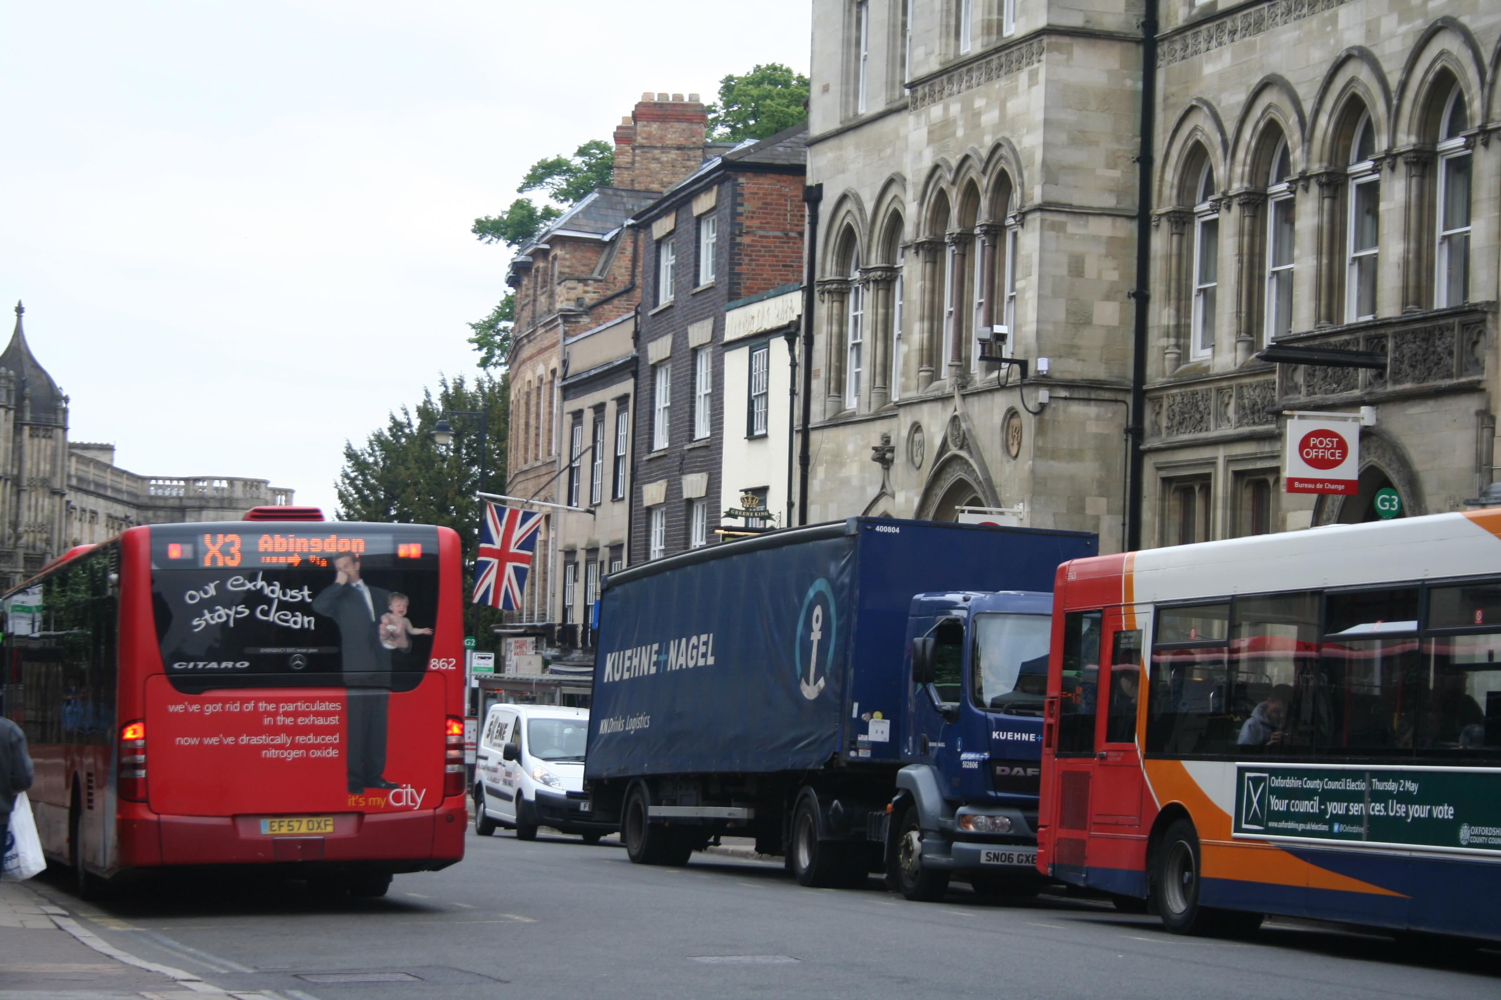

Heavy traffic – a leading source of particulate matter in urban areas
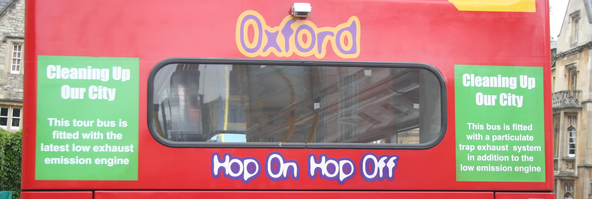
Air pollution is already known to increase the risk of respiratory and heart disease. Now it is recognized that the risk of developing lung cancer is significantly increased in people exposed to air pollution.

Visit the International Agency for Research on Cancer (IARC) website.

There are effective ways to reduce air pollution, and given the impacts of pollution, they should be put into practice sooner rather than later. As the major sources of pollution are the result of human activity, much can and should be done to protect the world’s population from exposure, especially those in urban and industrial areas.

A potential solution – low exhaust emission engine and particulate trap exhaust system

Air pollution and low birth weight

A recent study (by the Centre for Research in Environmental Epidemiology in Barcelona) has shown that children born to mothers who live in areas with air pollution and dense traffic are more likely to have low birth weight and smaller head circumferences. Even in areas with relatively low levels of air pollution, babies were smaller – well below the European Union accepted limits.

The study found that for every increase of 5 micrograms (µg) per cubic metre of particulate matter, the risk of low birth weight increased by 18 per cent. Although causation has not been proved, the link is a very strong one. The authors state that a substantial proportion of cases of low birth weight could be prevented in Europe if urban air pollution, especially particulate matter, was reduced.

© Pearson Education Ltd 2015.

For more information about the Pearson Baccalaureate series please visit www.pearsonbacconline.com

Low birth weight is a concern because it frequently predicts poor health for individuals, both as children and later as adults. A smaller head circumference could predict problems with neurodevelopment.

The research was based on 12 countries, involving over 74 000 women between 1994 and 2011. It included a range of environments from rural to inner city. Other factors, such as smoking, were also included. In terms of location, poor people living in inner city areas, living on a poor diet, and where there was more traffic, were more likely to have babies with low birth weight.

It is possible to reduce air pollution, although the advice is not always followed. The introduction of a low-emission zone in London has had little effect on the concentration of particulate matter, although the mix of vehicles has changed. UK policy makers have resisted attempts to change diesel-powered taxis (which contribute 20 per cent of London’s locally generated particulate matter) to cleaner petrol-powered ones.

Smog in Harbin, China

Dense smog in the north-eastern Chinese city of Harbin led to visibility of less than 10 metres and pollution levels 40 times the recommended daily level. All highways across Heilongjiang province were shut. In Harbin (population 11 million), the airport was closed and all primary and middle schools were shut.

In the city, measurements of PM2.5, the smallest particulate matter (diameter 2.5 micrometres) reached 1000 micrograms per cubic metre in places. This surpassed the peak of 900 that shocked Beijing residents in January's so-called airpocalypse. PM2.5 is particularly dangerous because the particles are small enough to penetrate deep into the lungs and enter the bloodstream. The WHO recommended level for daily exposure is just 25.

Officials blamed the first day of winter heating in the city, low winds, and the burning of crop stubble as well as vehicle emissions. China remains heavily dependent on coal, which accounts for 68.4 per cent of energy usage.

Visibility across most of neighbouring Jilin province was less than 500 metres. Trains were delayed, most highways closed and all flights from Changchun airport delayed. Emergency measures included closing schools and kindergartens and ordering cars with odd- and even-numbered licence plates to keep off the roads on alternate days. As a long-term measure, this could back-fire as it encourages people to have a second car, often an older and more polluting one. It has been suggested that China will have to pay over $800 billion to combat air pollution

Questions

1 | What do the letters IARC stand for? | [1 mark]
 | International Agency for Research on Cancer
2 | How many deaths worldwide were attributed to particulate matter in 2010? | [1 mark]
 | 2.1 million
3 | How many cases of lung cancer worldwide are said to be caused by air pollution? | [1 mark]
 | 223 thousands
4 | Where in the world does air pollution have the greatest impact? | [2 marks]
 | Low and middle income countries
5 | Why is it such a problem? | [2 marks]
 | Killing many people and causing cancer to spread among the people.
6 | Describe the link between air pollution and low birth weight. | [2 marks]
 | 18% increase of low birth weight from every increase of 5 micrograms per cubic meter of particulate matter
7 | Why is low birth weight a problem? | [2 marks]
 | predicts poor health for individuals, both as children and later as adults. A smaller head circumference could predict problems with neurodevelopment.
8 | Why was air quality a problem in Harbin in October 2013 | [3 marks]
 | Smog, poor vision, health risks, children getting sick, expensive to fix, lung damage

© Pearson Education Ltd 2015.

For more information about the Pearson Baccalaureate series please visit www.pearsonbacconline.com

